151220129 计科 吴政亿

厚书 3.3.2

(3) 由a与b组成的，后缀为aaa, aab, aba, abb的串

厚书 3.3.5

(1) $定义β为所有非元音小写字母的集合，$ 则其正则表达式为 $β^{*}a{\left(a | β\right)}^{*}e{\left(e | β\right)}^{*}i{\left(i | β\right)}^{*}o{\left(o | β\right)}^{*}u{\left(u | β\right)}^{*}$

厚书 3.4.1

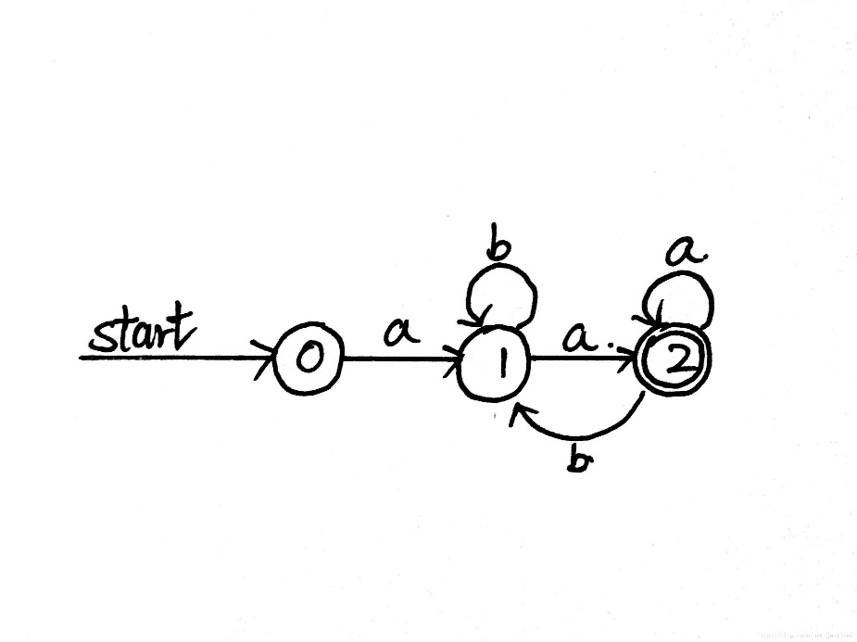

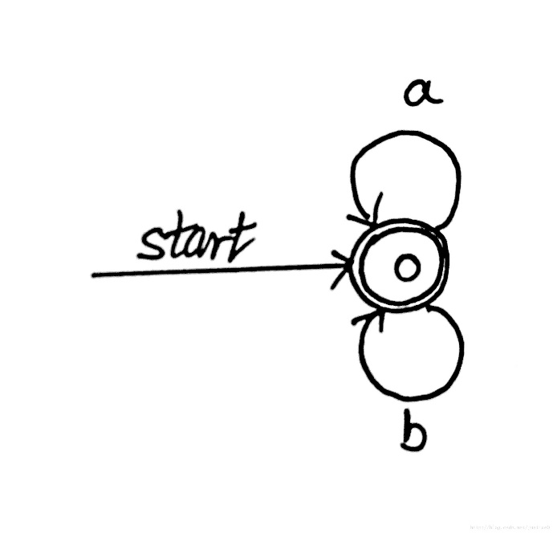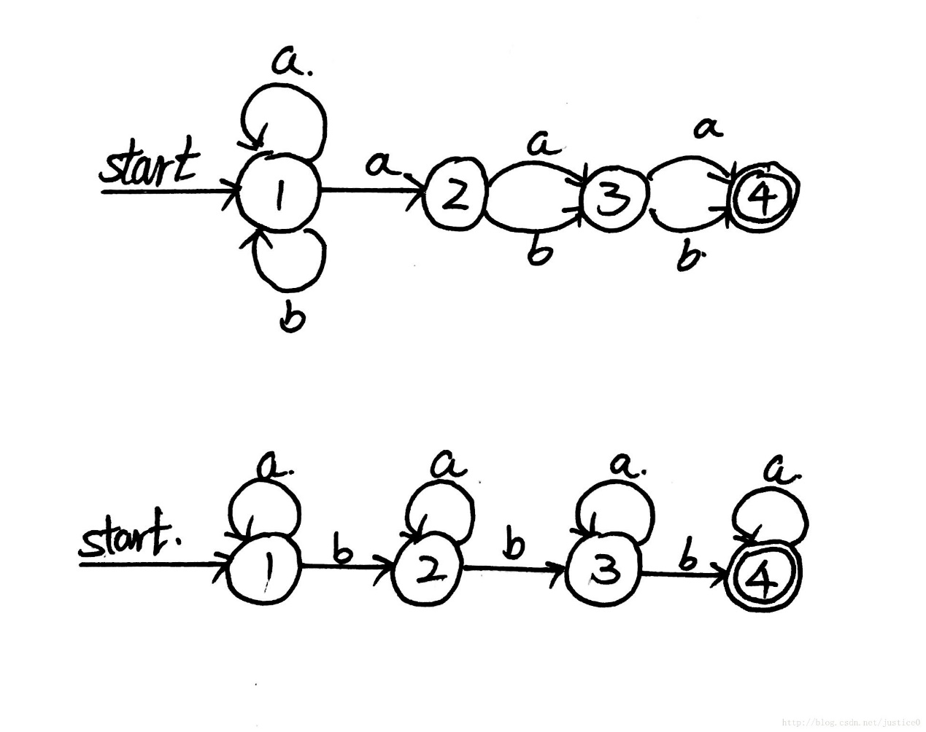

厚书 3.6.4

1. 0->1->0->1->2->3
2. 0->3->0->1->2->3

接受

厚书 3.6.5

(2)

|  |  |  |  |
| --- | --- | --- | --- |
| **状态** | **a** | **b** | ε |
| 0 | {1} | ϕ | {3} |
| 1 | ϕ | {2} | {0} |
| 2 | ϕ | {3} | {1} |
| 3 | {0} | ϕ | {2} |

厚书 3.7.1

(3)

|  |  |  |  |
| --- | --- | --- | --- |
| **NFA状态** | **DFA状态** | **a** | **b** |
| {0,1,2,3} | A | A | A |

